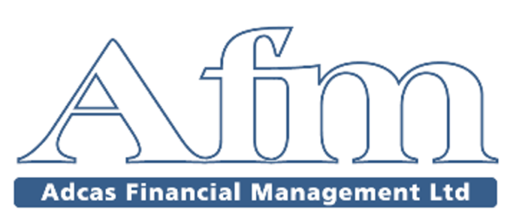

Privacy Notice
Adcas Financial Management Limited is regulated and authorised by the Financial Conduct Authority registration number 222123 and this privacy notice explains how we use any personal information we collect about you.

What information do we collect about you?
We collect information about you when you engage us for financial planning and advice services. This information will relate to your personal and financial circumstances. It may also include special categories of personal data such as data about your health, if this is necessary for the provision of our services.
We may also collect information when you voluntarily complete client surveys or provide feedback to us.

Why do we need to collect and use your personal data?
The primary legal basis that we intend to use for the processing of your data is for the performance of our contract with you. The information that we collect about you is essential for us to be able to carry out the services that you require from us effectively. Without collecting your personal data we’d also be unable to fulfil our legal and regulatory obligations.
Where special category data is required we’ll obtain your explicit consent in order to collect and process this information.

How will we use the information about you?
We collect information about you in order to provide you with the services for which you engage us.

Who might we share your information with?
If you agree, we may email you about other products or services that we think may be of interest to you.
If you agree, we’ll pass on your personal information to our group of companies so that they may offer you their products and services.
We won’t share your information for marketing purposes with companies outside our group of companies/other companies.
In order to deliver our services to you effectively we may send your details to third parties such as those that we engage for professional compliance, accountancy or legal services as well as product and platform providers that we use to arrange financial products for you.
Where third parties are involved in processing your data we’ll have a contract in place with them to ensure that the nature and purpose of the processing is clear, that they are subject to a duty of confidence in processing your data and that they’ll only act in accordance with our written instructions.
Where it’s necessary for your personal data to be forwarded to a third party we’ll use appropriate security measures to protect your personal data in transit, for example we may send information secure encrypted emails.
To fulfil our obligations in respect of prevention of money-laundering and other financial crime we may send your details to third party agencies for identity verification purposes.

How long do we keep hold of your information?
In principle, your personal data shouldn’t be held for longer than is required under the terms of our contract for services with you. However, we’re subject to regulatory requirements to retain data for specified minimum periods. We also reserve the right to retain data for longer than this due to the possibility that it may be required to defend a future claim against us. In any case, we’ll not retain your personal data for longer than six years.
You have the right to request deletion of your personal data. We’ll comply with this request, subject to the restrictions of our regulatory obligations and legitimate interests as noted above.

How can I access the information you hold about me?
You have the right to request a copy of the information that we hold about you. If you’d like a copy of some or all of your personal information please email or write to us using the contact details noted below.
When your personal data is processed by automated means you have the right to ask us to move your personal data to another organisation for their use.
We have an obligation to ensure that your personal information is accurate and up to date. Please ask us to correct or remove any information that you think is incorrect.

Marketing
We’d like to send you information about our products and services and those of other companies in our group which may be of interest to you. If you’ve agreed to receive marketing information, you may opt out at a later date.
You have a right at any time to stop us from contacting you for marketing purposes or giving your information to other members of the group. If you no longer wish to be contacted for marketing purposes, please contact us by email or post.

What can you do if you are unhappy with how your personal data is processed?
You also have a right to lodge a complaint with the supervisory authority for data protection. In the UK this is:
Information Commissioner's Office
Wycliffe House
Water Lane
Wilmslow
Cheshire
SK9 5AF
0303 123 1113 (local rate)

Changes to our privacy policy
We keep our privacy policy under regular review and we’ll place any updates on our website www.adcasltd.com to inform you of any changes when they occur. This privacy policy was last updated on 27/03/2018.

How to contact us
Please contact us if you have any questions about our privacy policy or information we hold about you: by email at admin@adcasltd.com
Or write to us at Adcas Financial Management Ltd, 90 Whitegate Drive, Blackpool FY3 9DA

